

**Photographyholic**

Group 9

Wrtiiten by :

**Abdul Halim Izzul Islam**

**Abdurrahman Awaludin Yasuhide Nasution**

**Naufal Bima Raifan**

Faculty:

**Bagus Bayu Kencana, S.Kom**

Class :

**2SE3**

CEP CCIT

FAKULTAS TEKNIK UNIVERSITAS INDONESIA

2022

**PROJECT ON**

*Photographyholic*

**Developed by**

**Abdul Halim Izzul Islam**

**Abdurrahman Awaludin Yasuhide**

**Naufal Bima Raifan**

**Photographyholic**

Batch Code : 2SE3

Start Date : 12 June 2022  
End Date : 22 June 2022

Name of Faculty : Bagus Bayu Kencana, S.Kom

Names of Developer :

Abdul Halim Izzul Islam

Abdurrahman Awaludin Yasuhide Nasution

Naufal Bima Raifan

Date of Submission:

**CERTIFICATE**

This is to certify that this report titled “Photographyholic” embodies the original work done by Abdul Halim Izzul Islam, Abdurrahman Awaludin Yasuhide Nasution, Naufal Bima Raifan. Project in partial fulfillment of their course requirement at NIIT.

Coordinator:

Bagus Bayu Kencana, S.Kom



**ACKNOWLEDGEMENT**

Praise and gratitude the author goes to the presence of God Almighty for His blessings and grace, we were able to complete this project task both in the form of presentations and papers on time. We don't forget to say thank you in particular to Mr. Bagus Bayu Kencana, lecturers and other lecturers who always help.

The project paper entitled “Photographyholic” is submitted as a requirement for the 2022 project assignment.

The author hopes that this paper can be useful for all so that it can increase knowledge and insight. The author realizes that this paper is far from perfect. Therefore, the author really expects all suggestions and criticisms from readers that are constructive for the perfection of this paper.Finally, I hope this paper can provide many benefits for the readers.

\

sssssssssss

**System Summary**:

In this world of photography, six out of ten people expect there to be an online content place in the form of the world of photography. some of them usually go directly to websites like pinterest to get more information about photography. And their decisions are often influenced by content that is less interesting for the world of photography.

Our project aims to support photographers by creating an attractive photo-storage platform for everyone to see. This platform will provide a place for photographers to put beautiful images. Besides that, this project also helps photographers to find their clients by looking at the work they put on this platform. This online phtography platform will be developed using HTML, CSS.

**SYSTEM ANALYSIS**

1. Home

**DESIGN INTERFACE &**

**IMPLEMENTATION**

2. Gallery

**DESIGN INTERFACE &**

**IMPLEMENTATION**

**DESIGN INTERFACE &**

**IMPLEMENTATION**

\

sssssssssss

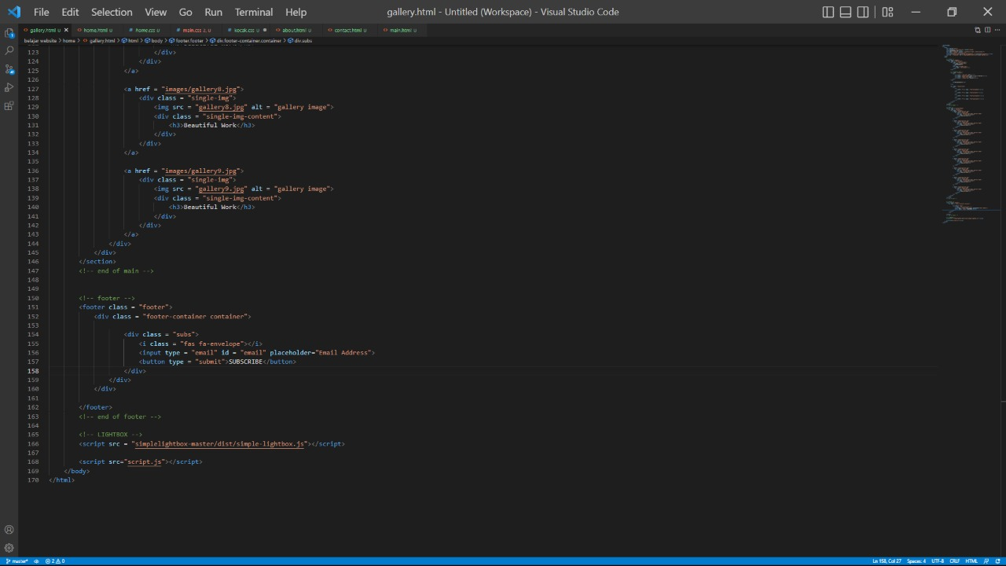

**DESIGN INTERFACE &**

**IMPLEMENTATION**

**DESIGN INTERFACE &**

**IMPLEMENTATION**

3.About

\

sssssssssss

**DESIGN INTERFACE &**

**IMPLEMENTATION**

4. Contact

\

sssssssssss

\

sssssssssss

**DESIGN INTERFACE &**

**IMPLEMENTATION**

**CONFIGURATION**

**Hardware:** - Lenovo m720q

- Asus Zenbook 14

**Operating System:** Windows 11

**Software:** - Visual Studio Code

- Microsoft Word

|  |  |  |
| --- | --- | --- |
| **PROJECT FILES DETAILS** | | |
| **S.No** | **File Name** | **Remarks** |
| 1 | Phoyographyholic.docx | Microsoft word that contains report |
| 2 | Photographyholic.pptx | Microsoft power point that contains presentation |
| 3 | Link youtube kelompok 9 | This text files contains youtube link video |
| 4 | Project 3.zip | Contains our source code |